8.39: In the notation of Example 8.10, with the smaller glider denoted as A, conservation of momentum gives 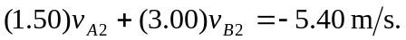 The relative velocity has switched direction, so 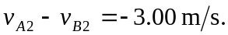 Multiplying the second of these relations by (3.00) and adding to the first gives with the minus sign indicating a velocity to the left. This may be substituted into either relation to obtain 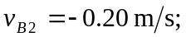 or, multiplying the second relation by (1.50) and subtracting from the first gives 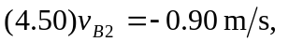which is the same result.

